Instacart Shopping Data

Milestone Project Report

Sava Dashev

Problem statement

The online shopping got firm grip on customers. All type of products are offered. In the last few years, we have large increase on groceries that are offered online. Many stores support ordering online and picking at store.

How do the stores prepare to better serve their customers? That is the goal. What products do the customers order most often? Which products are bought together? How often do the customers come back?

These questions help stores to serve better customers. There is more. How can we divide customers into groups related to the behavior they present online? Are there preferences to a particular day, or particular hour? Do the customers coming more often buy the same products as these coming once a month?

Dividing customers in meaningful groups helps predicting what these customers may order. Also, with segmentation we may create incentives targeting that segment based on what these customers previously ordered.

This survey will try to use unsupervised learning to separate customers into groups. The grocery retailer may want to use segmentation to target with ads different groups of customers and create incentives for these customers to come back.

Also, segmentation may help with planning inventory and cut the costs for the company. This will be done by predicting how much of each product may be sold.

Dataset

The data is collected in 2017. It is from old Kaggle competition. The zip file contains 5 files with separated data for transactions.

The main file contains information about each order. In the file, each row is data for one order. The values in the row are user ID, the date and time of the order, how many days elapsed since the prior order. Each order has order ID. We also have counter variable, how many orders each customer has placed.

The orders are divided in three groups. The largest group is called “prior”. These are all orders, for each customer, but the last one. The last order for each customer is places in one of two groups. One of the groups is called “train”, and the other group is called “test”. The train group consists of last order for about ⅔ of all users. This last order will be used to train model to predict items in that order. The rest of the last orders for the remainder of the users will be used for testing the model in the competition. These orders do not have data available for the items in them.

The user id-s are randomized. There is no data how much each item cost, or from which store it was ordered.

Two other files contain the data for each order. One of the files contain “prior” items order and the other contain “train” items. Each row in this table has values connecting order ID and product ID. The other bits of information for this table is “reordered” - the value of 0 shows that this is the first time the user placing order for that item, and 1 otherwise. The last entry is a number-counter is the item 1st, 2nd, 3rd … in the basket for that order.

The description of each product is distributed in three files. The first file contains the name of each product and two other values: aisle ID, and department ID. The last two tables, very small give each aisle ID name and each department ID name.

The data set is organized efficiently into very large data base. The bulk of the data is in the files containing the items purchased prior and train data.

Cleaning data

The set of data was relatively clean.

We read each file into separate dataframe. We looked for missing values. For each numerical variable, we got the same number of entries, as the number of rows. The only exception was the variable showing days since prior order. For each user, the first order has NaN value, nothing to start counting from. The data had to use NaN (an abbreviation describing Not-a-Number), because sometimes there were two orders in the same day!

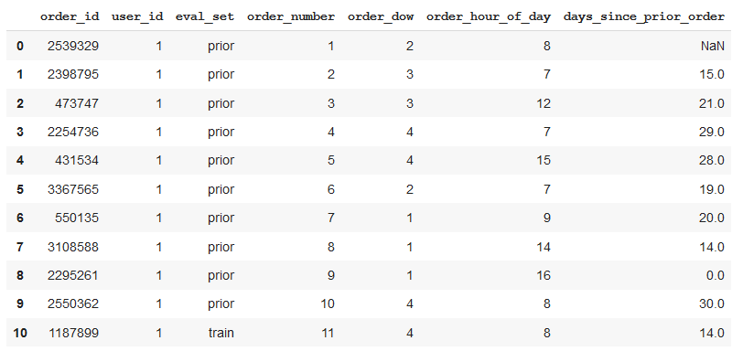

We also checked for duplicated orders. All orders have unique numbers, no duplicates for train, test and prior. Each order belongs to exactly ONE set.

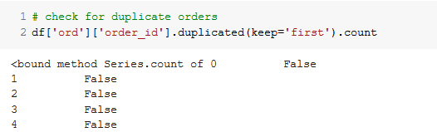

After checking data, we combined data into one dataframe for EDA and further processing. First, we combined prior and train dataframes. These two dataframes have the same type of data. Next, we combined prior and train data with orders dataframe.

We collected products, aisles and departments into one dataframe containing the ID-s and the name of each product, department and aisle.

The last step was to combine the orders data frame and the products data frames.

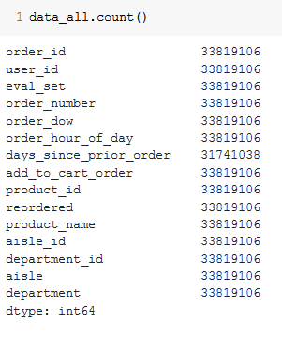

When we finished, we checked the combined data and saved it into a large file.

Exploratory analysis

The distribution of orders over time follows two different patterns. Users are most active ordering Saturday and Sunday. Least active day is Wednesday.

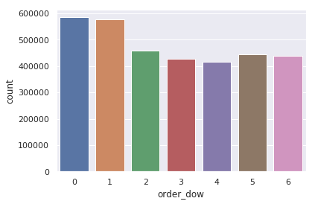

For each hour of day, Monday to Thursday the count of orders each day follows similar distribution. Users are most active around 10:00 am and 4:00 pm. Friday, Saturday and Sunday have only one local maximum of order counts.

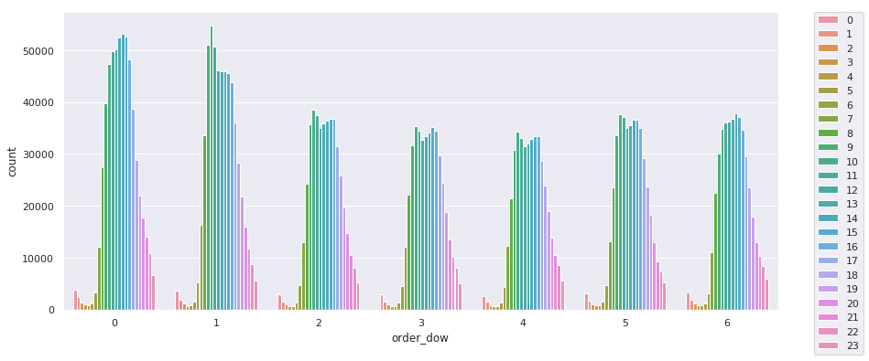

The number of orders per user is between 4 and 100. The most users have placed 4 orders.

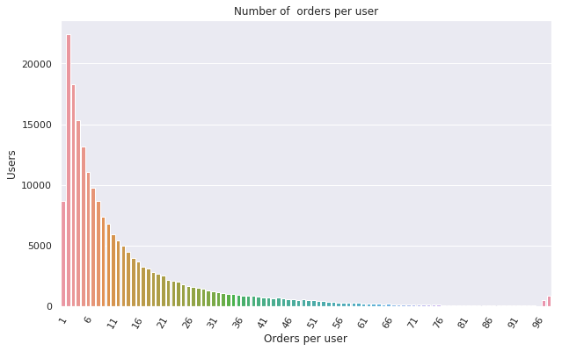

Most users placed small orders. The mode of number of items is 5. The largest order contain about 120 items. The distribution for number of items in order is right tail distribution.

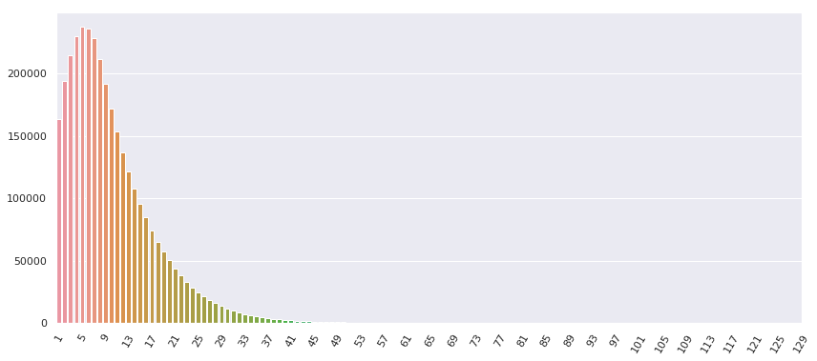

We look how often users shop for food. Grouping by days since prior order, we see picks of activities around 7, 14, 21 and 28 days.

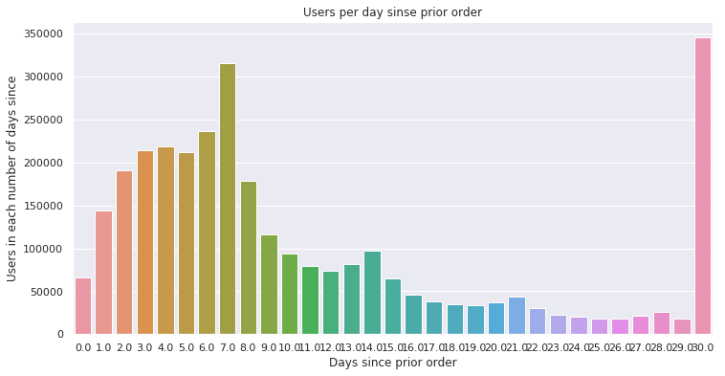

For some users, they place orders after more than 30 days. The data shows that we have 30 or more days since prior order.

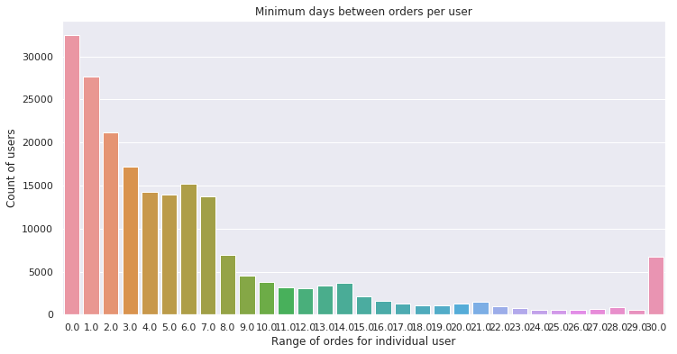

The maximum number of days between orders for some users is 30 days.

For another group of users, the number of days between orders is no more than 29 days. We have local pics around 7, 14 and 21 days. The most users have 21 days since prior order as max number of days between orders.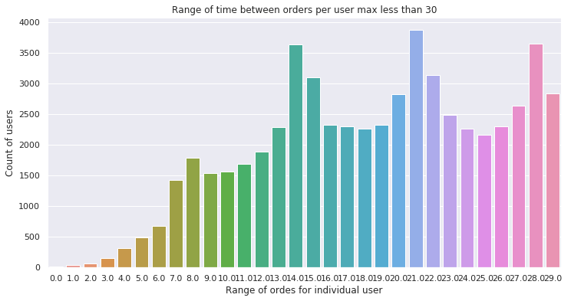

We can also see the least number of days between orders. Some 30,000 users shopped more than once in the same day. And another group of 3,500 users, online shop no more often than once a month.

What items are most often ordered? Bananas and organic bananas are the first two items. In the first 30 most ordered items, more than half are organic.

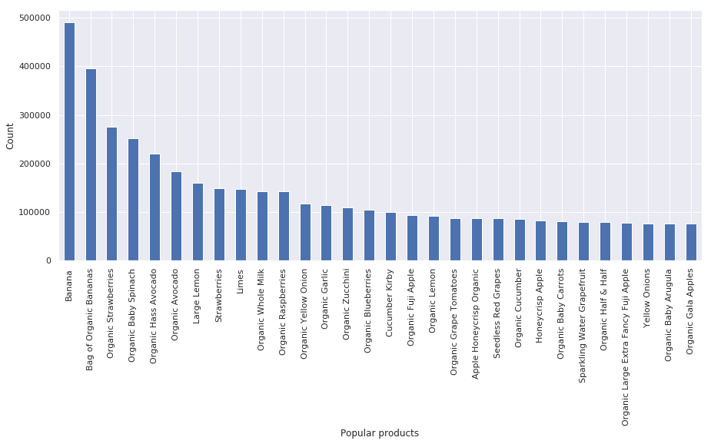

We also looked into most popular departments and aisles. The most popular aisles are fresh vegetables and fresh fruits, for the departments - diary eggs. The least popular is department is bulk.

|  |  |
| --- | --- |
| aisle |  |
| Fresh fruits | 3792661 |
| Fresh vegetables | 3568630 |
| Packaged vegetables fruits | 1843806 |
| Yogurt | 1507583 |
| Packaged cheese | 1021462 |
| Milk | 923659 |
| Water seltzer sparkling water | 878150 |
| Chips pretzels | 753739 |
| Soy lactose free | 664493 |
| Bread | 608469 |

Using our data, we can calculate reorder ratio.

The reorder ratio varies with time. Grouping items by day and time of day, the reorder ratio varies from 0.67 to 0.54.

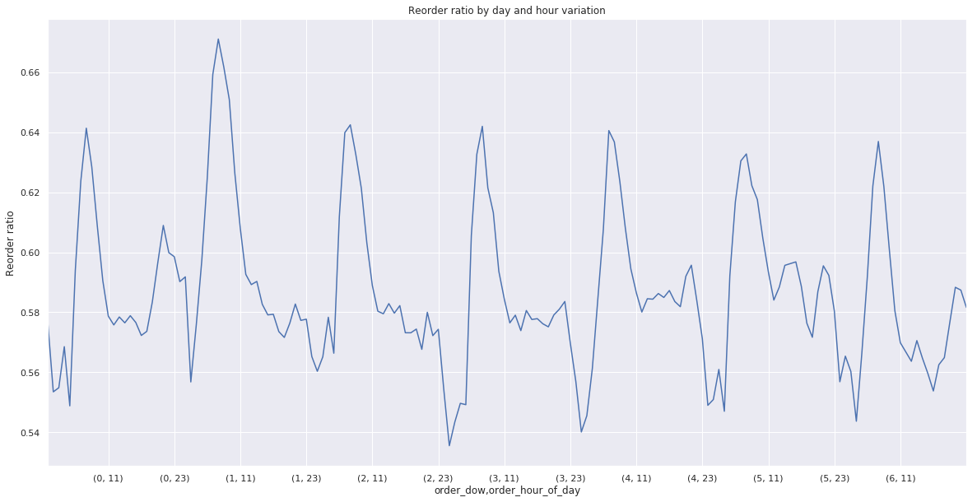

Reorder ratio varies with product also. We checked the level at which two different products with different ratios will be statistically significant. When the difference of reorder proportion is about 0.15, the products most likely belong to different populations. At lower levels, we failed to reject the hypothesis that the proportions belong to the same population.

Take for example for products 25015 (Raw Fit High Protein Vanilla Single Packet) and 25094 (Brown Sugar Blend) with corresponding total orders of 66 and 124, and reorders of 14 and 39. The reorder ratios are 0.212 and 0.314. We calculated that z-value is -1.498. The value to reject hypothesis is 1.960, so we fail to reject null hypothesis.

For the analysis, we wrote a function that will take two products and calculate the z-value under the null hypothesis. The function will reject the hypothesis, if z-value is higher than a given value or fail to reject. Also, the function will print information about the two products.

We also checked to see if the variables hour of the day and day of week will create distributions with different mean. To check it, we used a version of the function, that will accept as parameters two different days and times.

In most cases, we rejected the hypothesis that the reorder ratio proportion for two days and times belongs to the same set.

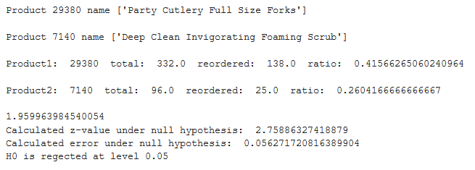

The departments reorder proportion vary greatly. We check for statistical significance. We choose two departments, with small number of items, and use the function to check if they belong to different populations. The hypothesis that the two department populations are from the same population is rejected.

We used two departments with small number of orders: “other” and “missing”. Other has total of 38086 orders and 15503 reorders, missing – 77396 orders and 30519 reorders. The reorder ratios are 0.407 and 0.394. Still, the null hypothesis is rejected.

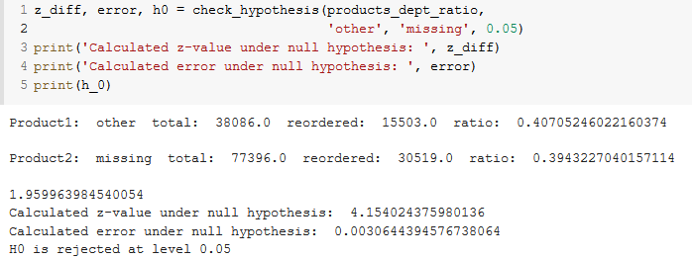

Notes

1. The data collected contains between 4 and 100 orders for each user. The last order for each user is either “train” or “test”. The rest of the orders are in “prior” category.

We investigating to which categories each user belongs. When counted, the total number of users and the total number of users in prior category is 206,209. The number of users in train is 131,209 and the number of users in test is 75,000. The number of the train and test adds up to 206,209. We can conclude that there is no overlap between the two sets, because the number of users in the two add up exactly to the total number of users in the two sets.

1. Some products were not ordered many times. We can apply Central Limit Theorem if the number of times ordered is more than 50, and success and failure to reorder is at least 5. There are about 38,000 such products.
2. With tens of thousands or thousands of orders, even small variation of the reorder proportion is statistically significant.

We used z-value to determine if two different product categories are different, or the shown difference is due by chance. In most cases, we used value of 0.05 for our tests.